Holiday Resort Unity
Coast Road, Brean
Burnham on Sea
TA8 2RB

09 April 2018

Our Ref: RET-225

Q U O T A T I O N

MAKE: Swift
MODEL: Alsace
SERIAL NUMBER: 022550h
PITCH NUMBER: B14

To take out the integrated dishwasher and replace with a free standing washing machine in its place (**please note the washing machine will not be integrated with a door**).

This would mean taking out the drawers next to the unit where the washing machine would sit and our engineers would have to make an open shelving unit next to the free standing washing machine. This means losing the drawer unit. (Please see attached photo).

MATERIALS: £330.00
LABOUR: £320.00
TRAVEL: £77.00

Sub-total £842.50
VAT £168.50

GRAND TOTAL £1011.00

Q U O T A T I O N

Holiday Resort Unity
Coast Road, Brean
Burnham on Sea
TA8 2RB

Our Ref: RET-225

I hereby authorise Surf Bay Leisure to carry out the repairs detailed in their quotation

SIGNATURE-----------------------------------------------------------------------

DATE --------------------------------------------------------------------------------

PLEASE SIGN AND RETURN AT YOUR EARLIEST CONVENIENCE

THANK YOU FOR YOUR CUSTOM

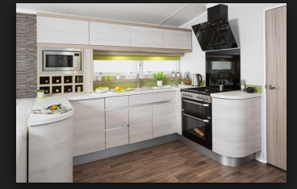 We would lose the drawers and these would
be replaced with an open shelving unit.

This is where the free standing washing machine would sit.

