
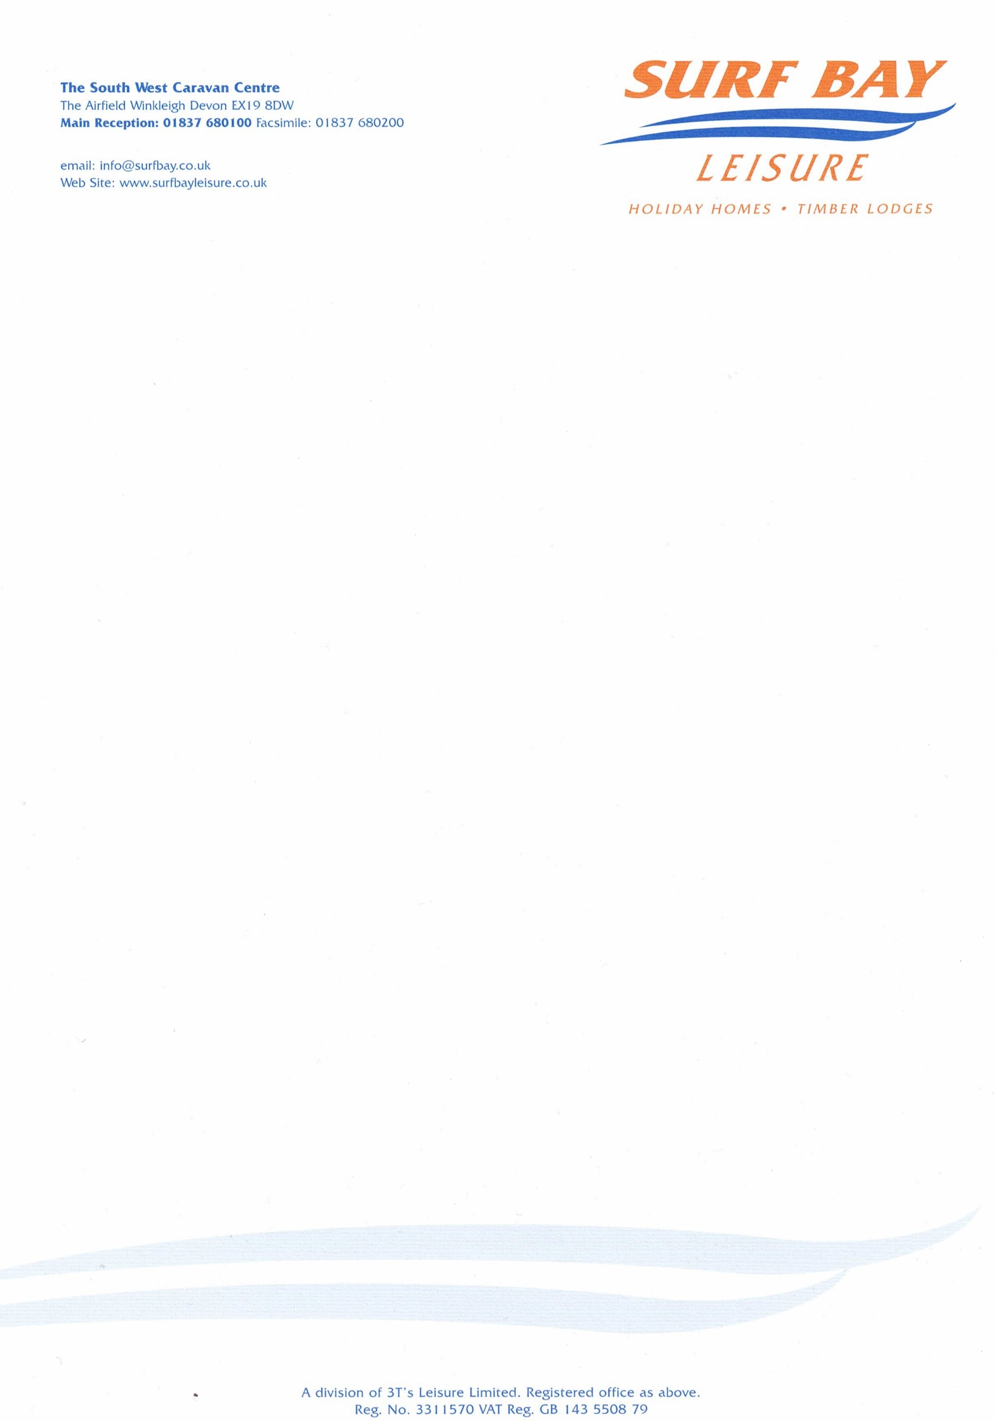

Ladram Bay Holiday Centre
Otterton
Nr Budleigh Salterton
EX9 7BX

27 July 2021

Our Ref: CHARGE-4339

Q U O T A T I O N

MAKE: Swift
MODEL: torronto lodge
SERIAL NUMBER: 036014h
PITCH NUMBER: Pv003

Replacement Bedside cabinet

MATERIALS: £71.55

DELIVERY: £10.00

Sub-total £81.55
VAT £16.31

TOTAL £97.86

Q U O T A T I O N

Ladram Bay Holiday Centre
Otterton
Nr Budleigh Salterton
EX9 7BX

Our Ref: CHARGE-4339

P/O No:

I hereby authorise Surf Bay Leisure to order parts and carry out work stated in this quote.

SIGNATURE-----------------------------------------------------------------------

PRINT--------------------------------------------------------------------------------

DATE --------------------------------------------------------------------------------

PLEASE SIGN AND RETURN AT YOUR EARLIEST CONVENIENCE

