
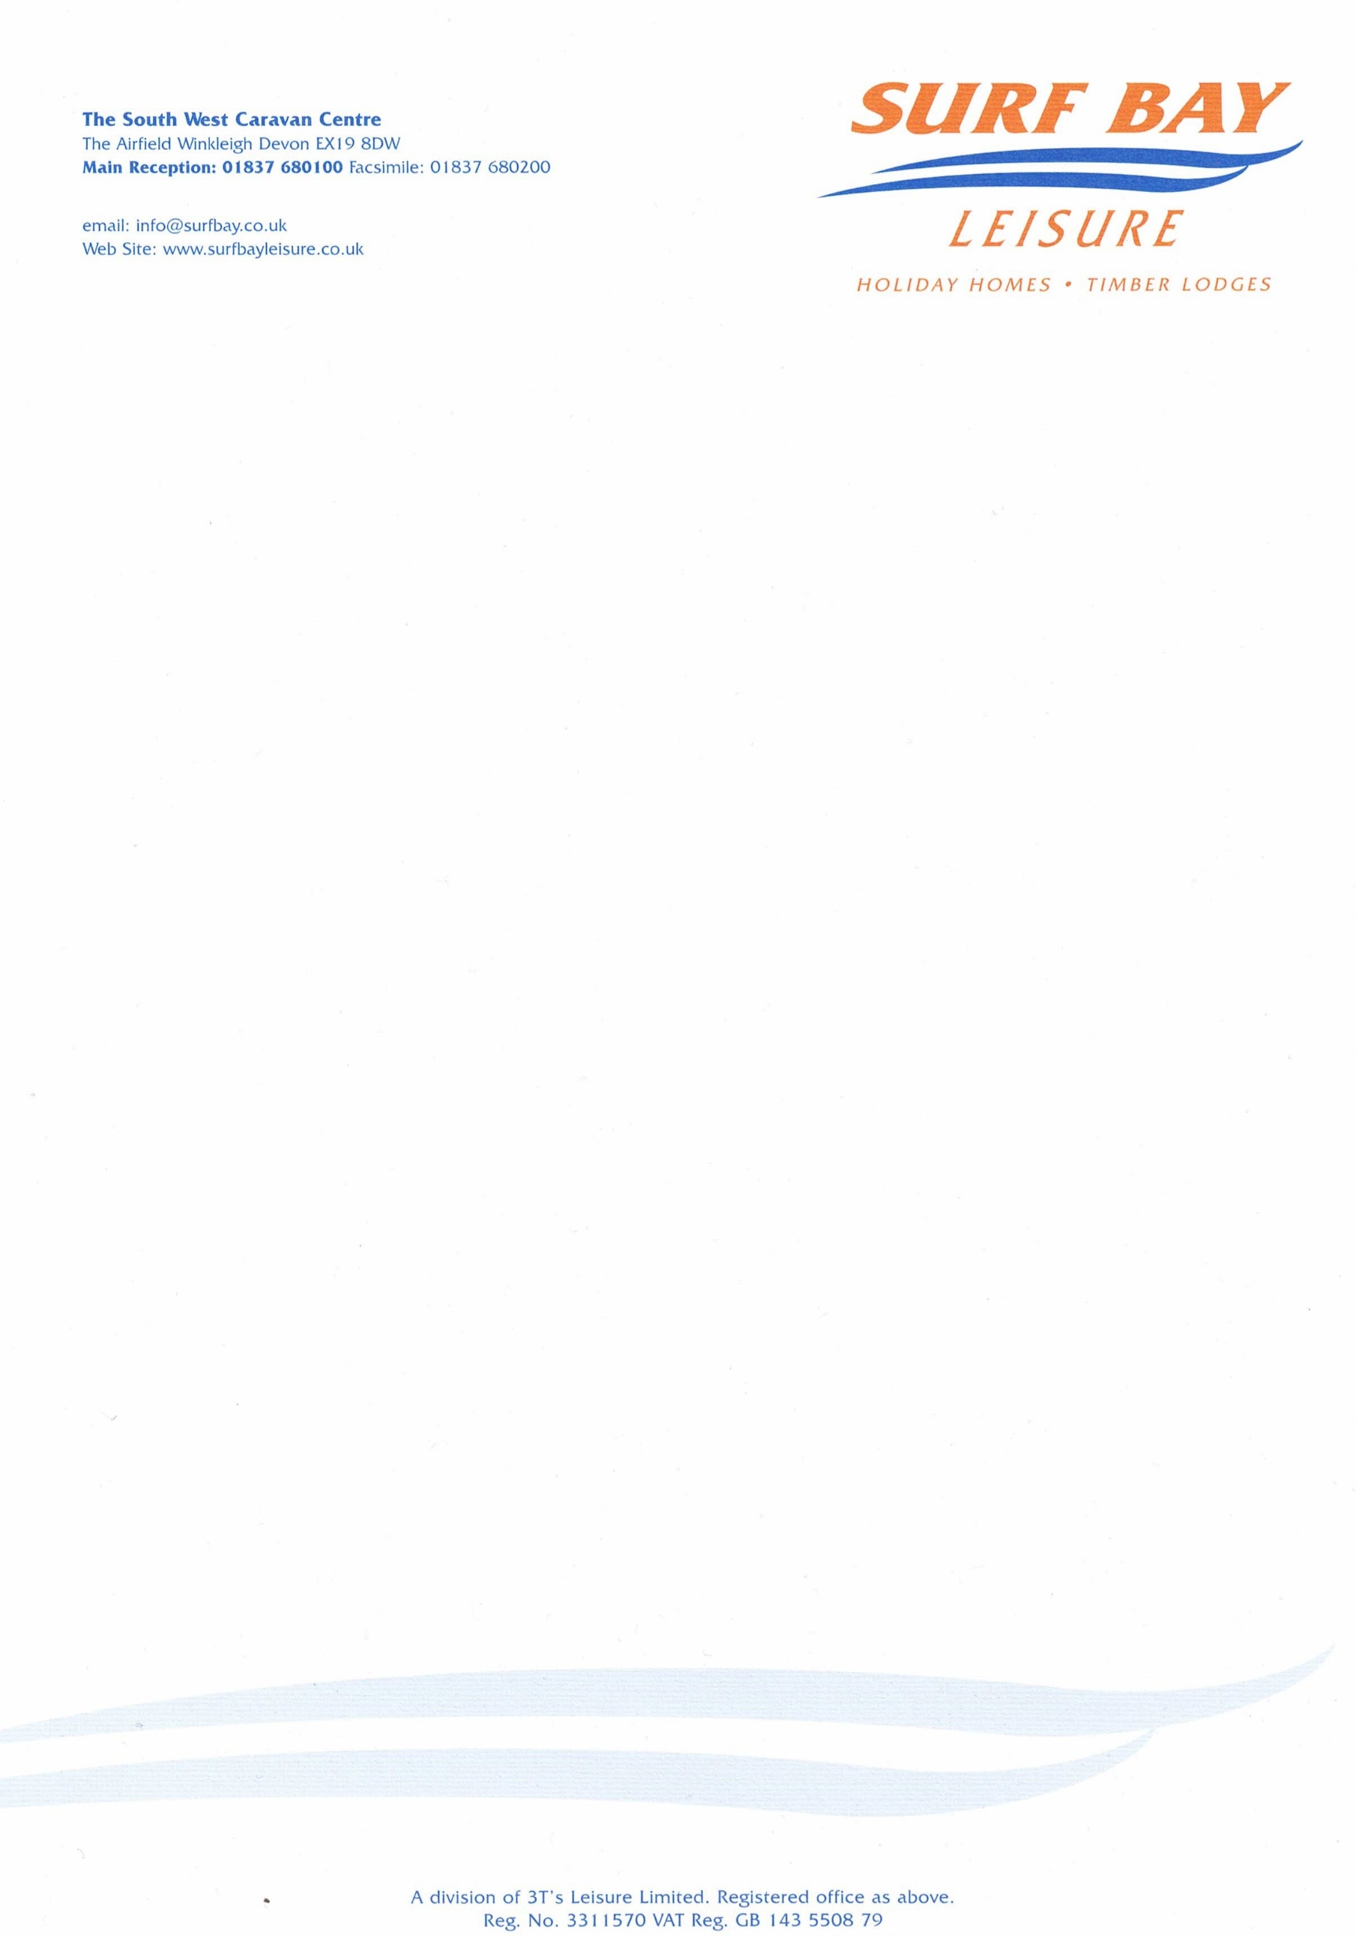

FAO Mr Parr
Warren Bay Holiday Park
Watchet
Minehead
TA23 0JR

02 February 2023

Our Ref: CHARGE-4884

Q U O T A T I O N

MAKE: Swift
MODEL: Moselle lodge
SERIAL NUMBER: 029278h
PITCH NUMBER: 63

1 x Shower access panel

MATERIALS: £40.24
DELIVERY: £10.00
Fitting is a Gesture of Good will

Sub-total £50.24
VAT £10.00

TOTAL £60.29

Q U O T A T I O N

Warren Bay Holiday Park
Watchet
Minehead
TA23 0JR

Our Ref: CHARGE-4884

P/O No:

I hereby authorise Surf Bay Leisure to order parts and carry out work stated in this quote.

Park is aware of this quote and repair work to be carried out.

SIGNATURE-----------------------------------------------------------------------

PRINT--------------------------------------------------------------------------------

DATE --------------------------------------------------------------------------------

PLEASE SIGN AND DATE AT YOUR EARLIET CONVENIENCE

Invoice details if different from above address:

Name:____________________________________________________

Address:__________________________________________________

__________________________________________________________

__________________________________________________________

Telephone:________________________________________________

Email:____________________________________________________

