
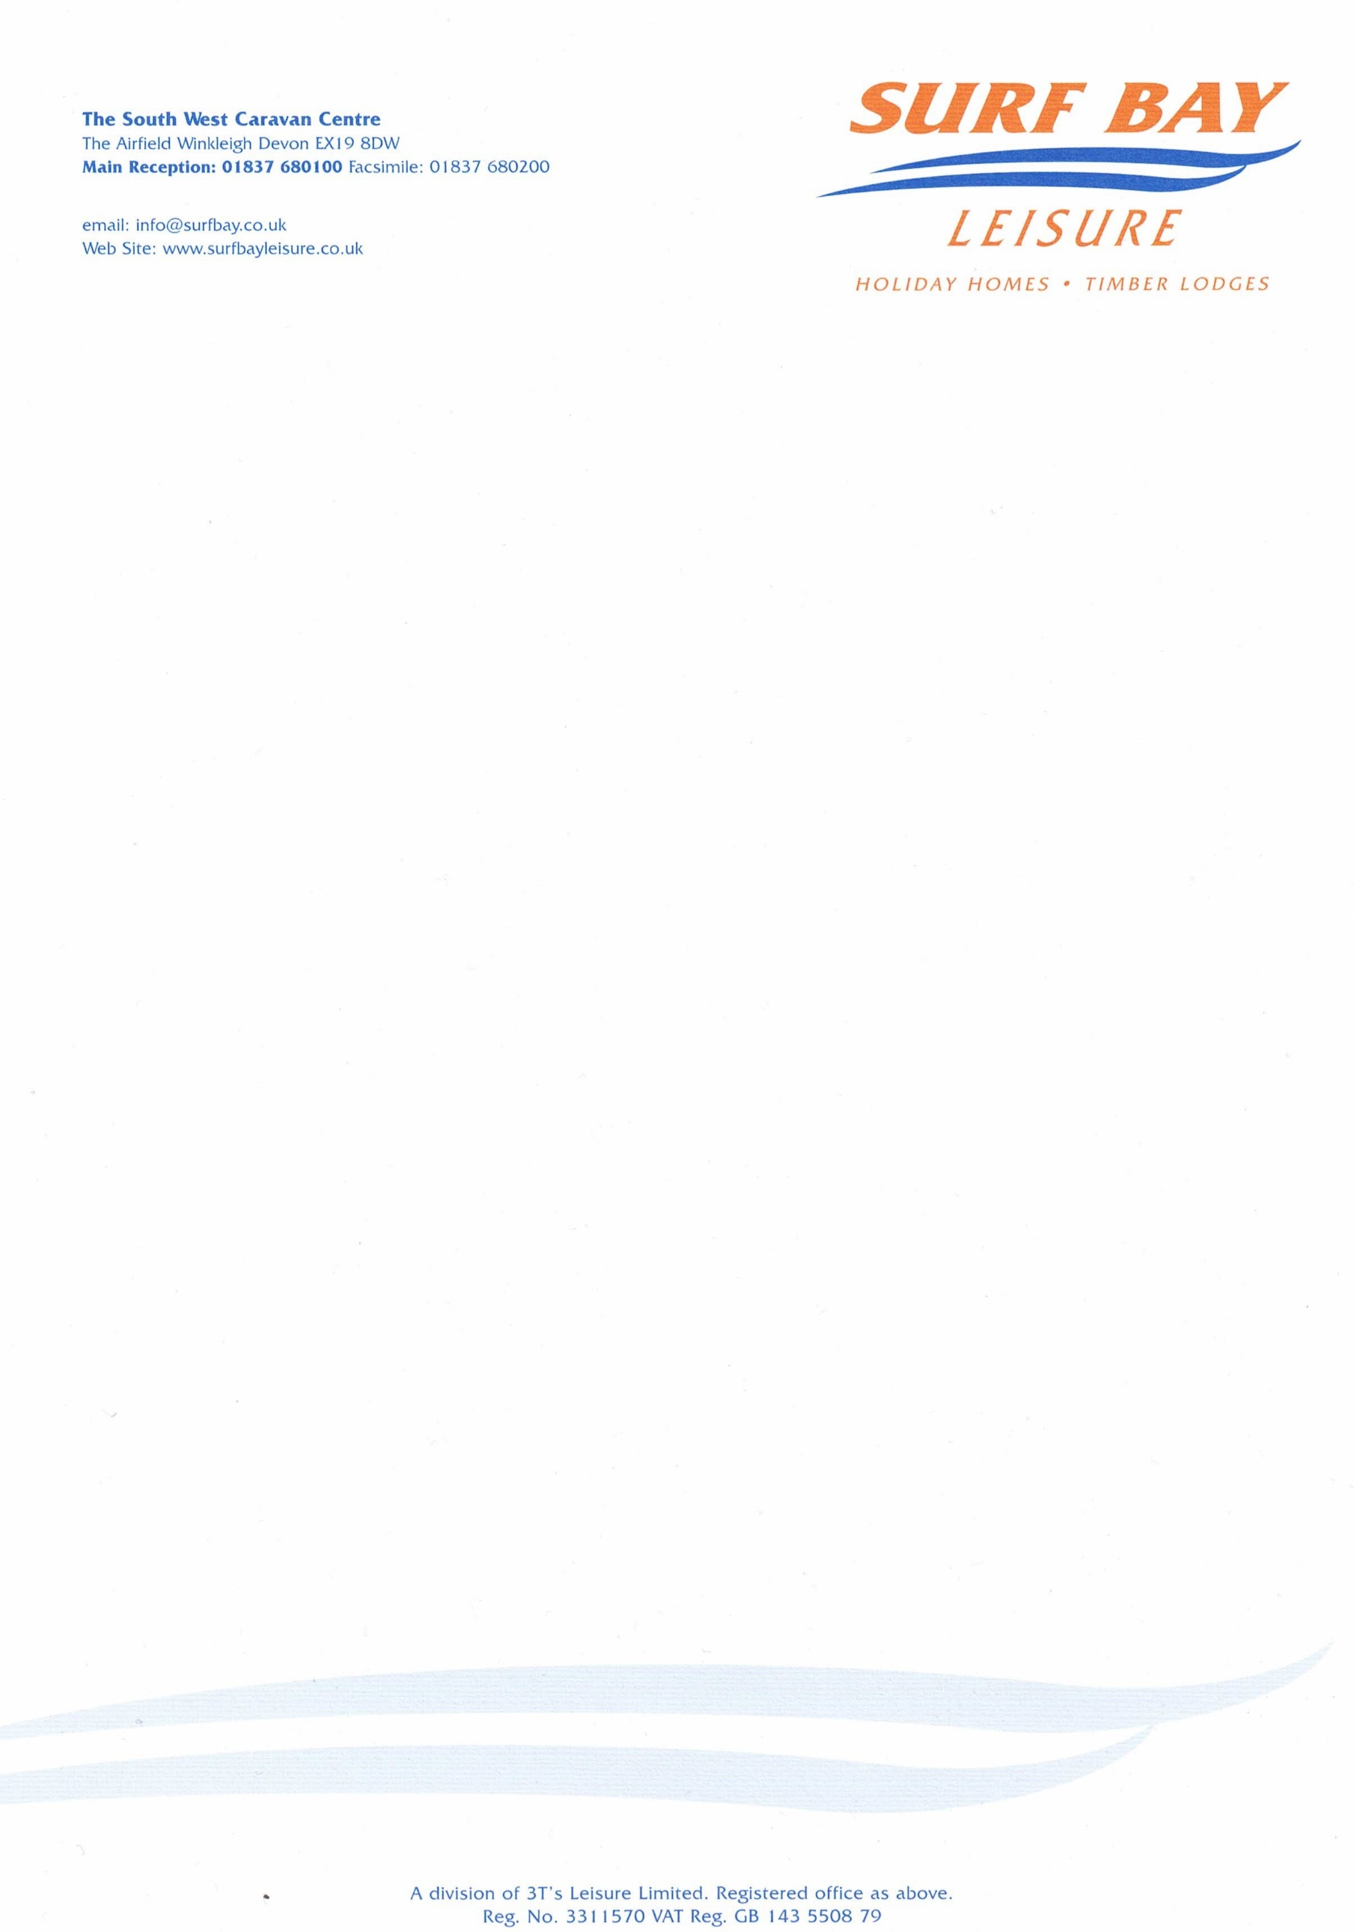

Perranporth Holiday Park
1 Crow Hill, Bolingey
Perranporth
TR6 0DG

09 February 2023

Our Ref: GW-9682

Q U O T A T I O N

MAKE: Swift
MODEL: Burgundy
SERIAL NUMBER: 040810H
PITCH NUMBER: 13

Set of base sofa cushions not in Swift Sheild
1 x B44858X @ £231.08
1 x B45128X @ £205.40
3 x B45248C @ £206.04 each

MATERIALS: £1054.60
DELIVERY: £ 20.00

Sub-total £1074.60
VAT £ 214.92

TOTAL £1289.52

Q U O T A T I O N

Perranporth Holiday Park
1 Crow Hill, Bolingey
Perranporth
TR6 0DG

Our Ref: GW-9682

P/O No:

I hereby authorise Surf Bay Leisure to order parts and carry out work stated in this quote.

Park is aware of this quote and repair work to be carried out.

SIGNATURE-----------------------------------------------------------------------

PRINT--------------------------------------------------------------------------------

DATE --------------------------------------------------------------------------------

PLEASE SIGN AND DATE AT YOUR EARLIET CONVENIENCE

Invoice details if different from above address:

Name:____________________________________________________

Address:__________________________________________________

__________________________________________________________

__________________________________________________________

Telephone:________________________________________________

Email:____________________________________________________

