
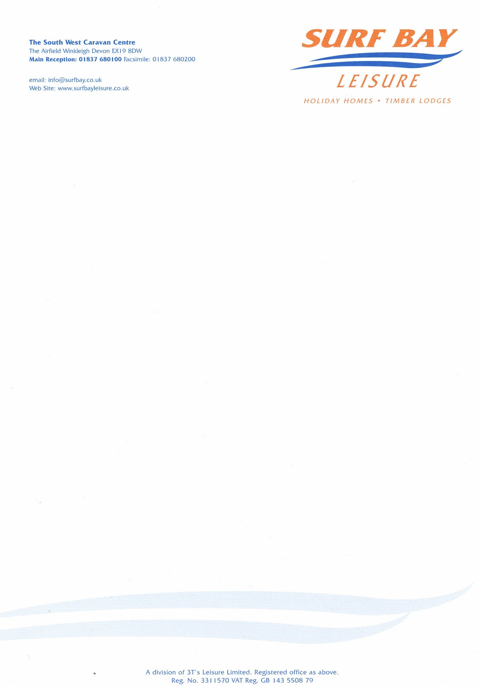

Surf Bay Leisure (Winkleigh)

EX19 8DW

20 July 2023

Our Ref: SBHP-667

Q U O T A T I O N

MAKE: Atlas
MODEL: Oakwood
SERIAL NUMBER: 23AT023397/14
PITCH NUMBER:

Replacement bargeboard and end cap, please note atlas have to supply a complete set

MATERIALS: £282.24

DELIVERY: £85.00

Sub-total £367.24
VAT £73.45

TOTAL £440.69

Q U O T A T I O N

Surf Bay Leisure (Winkleigh)

EX19 8DW

Our Ref: SBHP-667

P/O No:

I hereby authorise Surf Bay Leisure to order parts and carry out work stated in this quote.

Park is aware of this quote and repair work to be carried out.

SIGNATURE-----------------------------------------------------------------------

PRINT--------------------------------------------------------------------------------

DATE --------------------------------------------------------------------------------

PLEASE SIGN AND DATE AT YOUR EARLIET CONVENIENCE

Invoice details if different from above address:

Name:____________________________________________________

Address:__________________________________________________

__________________________________________________________

__________________________________________________________

Telephone:________________________________________________

Email:____________________________________________________

