
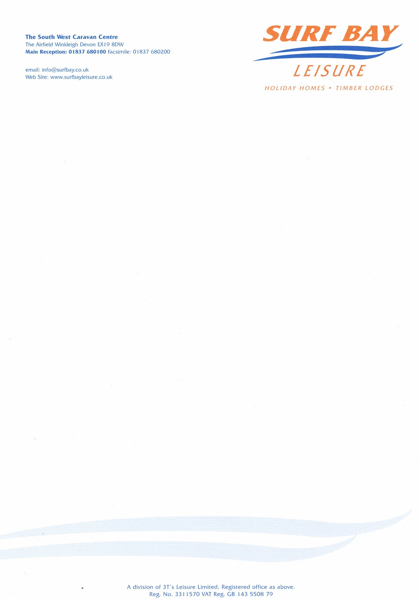

FAO Martyn
Harlyn Sands Holiday Park
Lighthouse Road, Trevose Head
Padstow
PL28 8SQ

10 August 2023

Our Ref: CHARGE-5113

Q U O T A T I O N

MAKE: SWIFT
MODEL: Margaux
SERIAL NUMBER: 031979H
PITCH NUMBER: 132

Full set of doors for Kitchen £574.62
3 Doors in Lounge £122.28

MATERIALS: £696.90
DELIVERY: £ 20.00

Sub-total £716.90
VAT £143.38

TOTAL £860.28

Q U O T A T I O N

Harlyn Sands Holiday Park
Lighthouse Road, Trevose Head
Padstow
PL28 8SQ

Our Ref: CHARGE-5113

P/O No:

I hereby authorise Surf Bay Leisure to order parts and carry out work stated in this quote.

Park is aware of this quote and repair work to be carried out.

SIGNATURE-----------------------------------------------------------------------

PRINT--------------------------------------------------------------------------------

DATE --------------------------------------------------------------------------------

PLEASE SIGN AND DATE AT YOUR EARLIET CONVENIENCE

Invoice details if different from above address:

Name:____________________________________________________

Address:__________________________________________________

__________________________________________________________

__________________________________________________________

Telephone:________________________________________________

Email:____________________________________________________

