
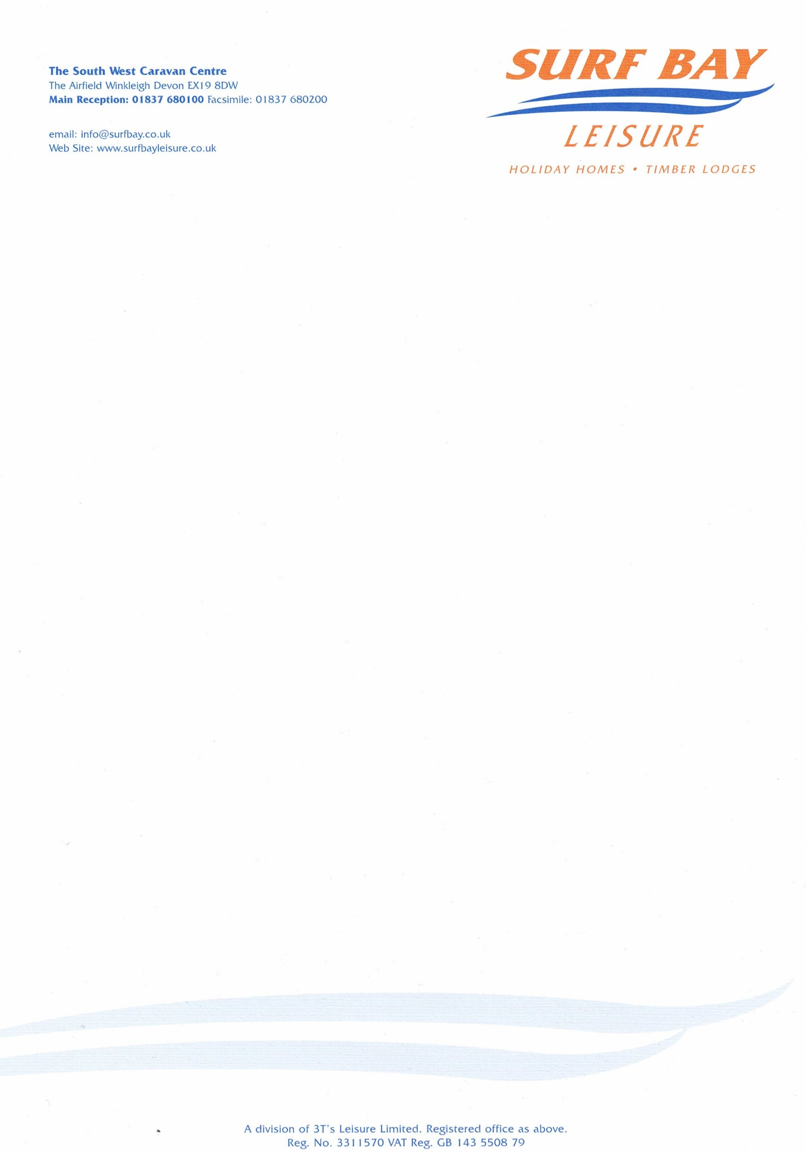

Venturer Transport

16 October 2023

Our Ref: CHARGE-5169

Q U O T A T I O N

MAKE: swift
MODEL: moselle lodge
SERIAL NUMBER: 040790h
PITCH NUMBER:

transport damage, damage to bargeboard, As you are looking at the van it’s left hand side 1722845

MATERIALS: £151,72

DELIVERY: £20.00

Sub-total £171.72
VAT £34.34

TOTAL £206.06

Q U O T A T I O N

Venturer Transport

Our Ref: CHARGE-5169

P/O No:

I hereby authorise Surf Bay Leisure to order parts and carry out work stated in this quote.

Park is aware of this quote and repair work to be carried out.

SIGNATURE-----------------------------------------------------------------------

PRINT--------------------------------------------------------------------------------

DATE --------------------------------------------------------------------------------

PLEASE SIGN AND DATE AT YOUR EARLIET CONVENIENCE

Invoice details if different from above address:

Name:____________________________________________________

Address:__________________________________________________

__________________________________________________________

__________________________________________________________

Telephone:________________________________________________

Email:____________________________________________________

