
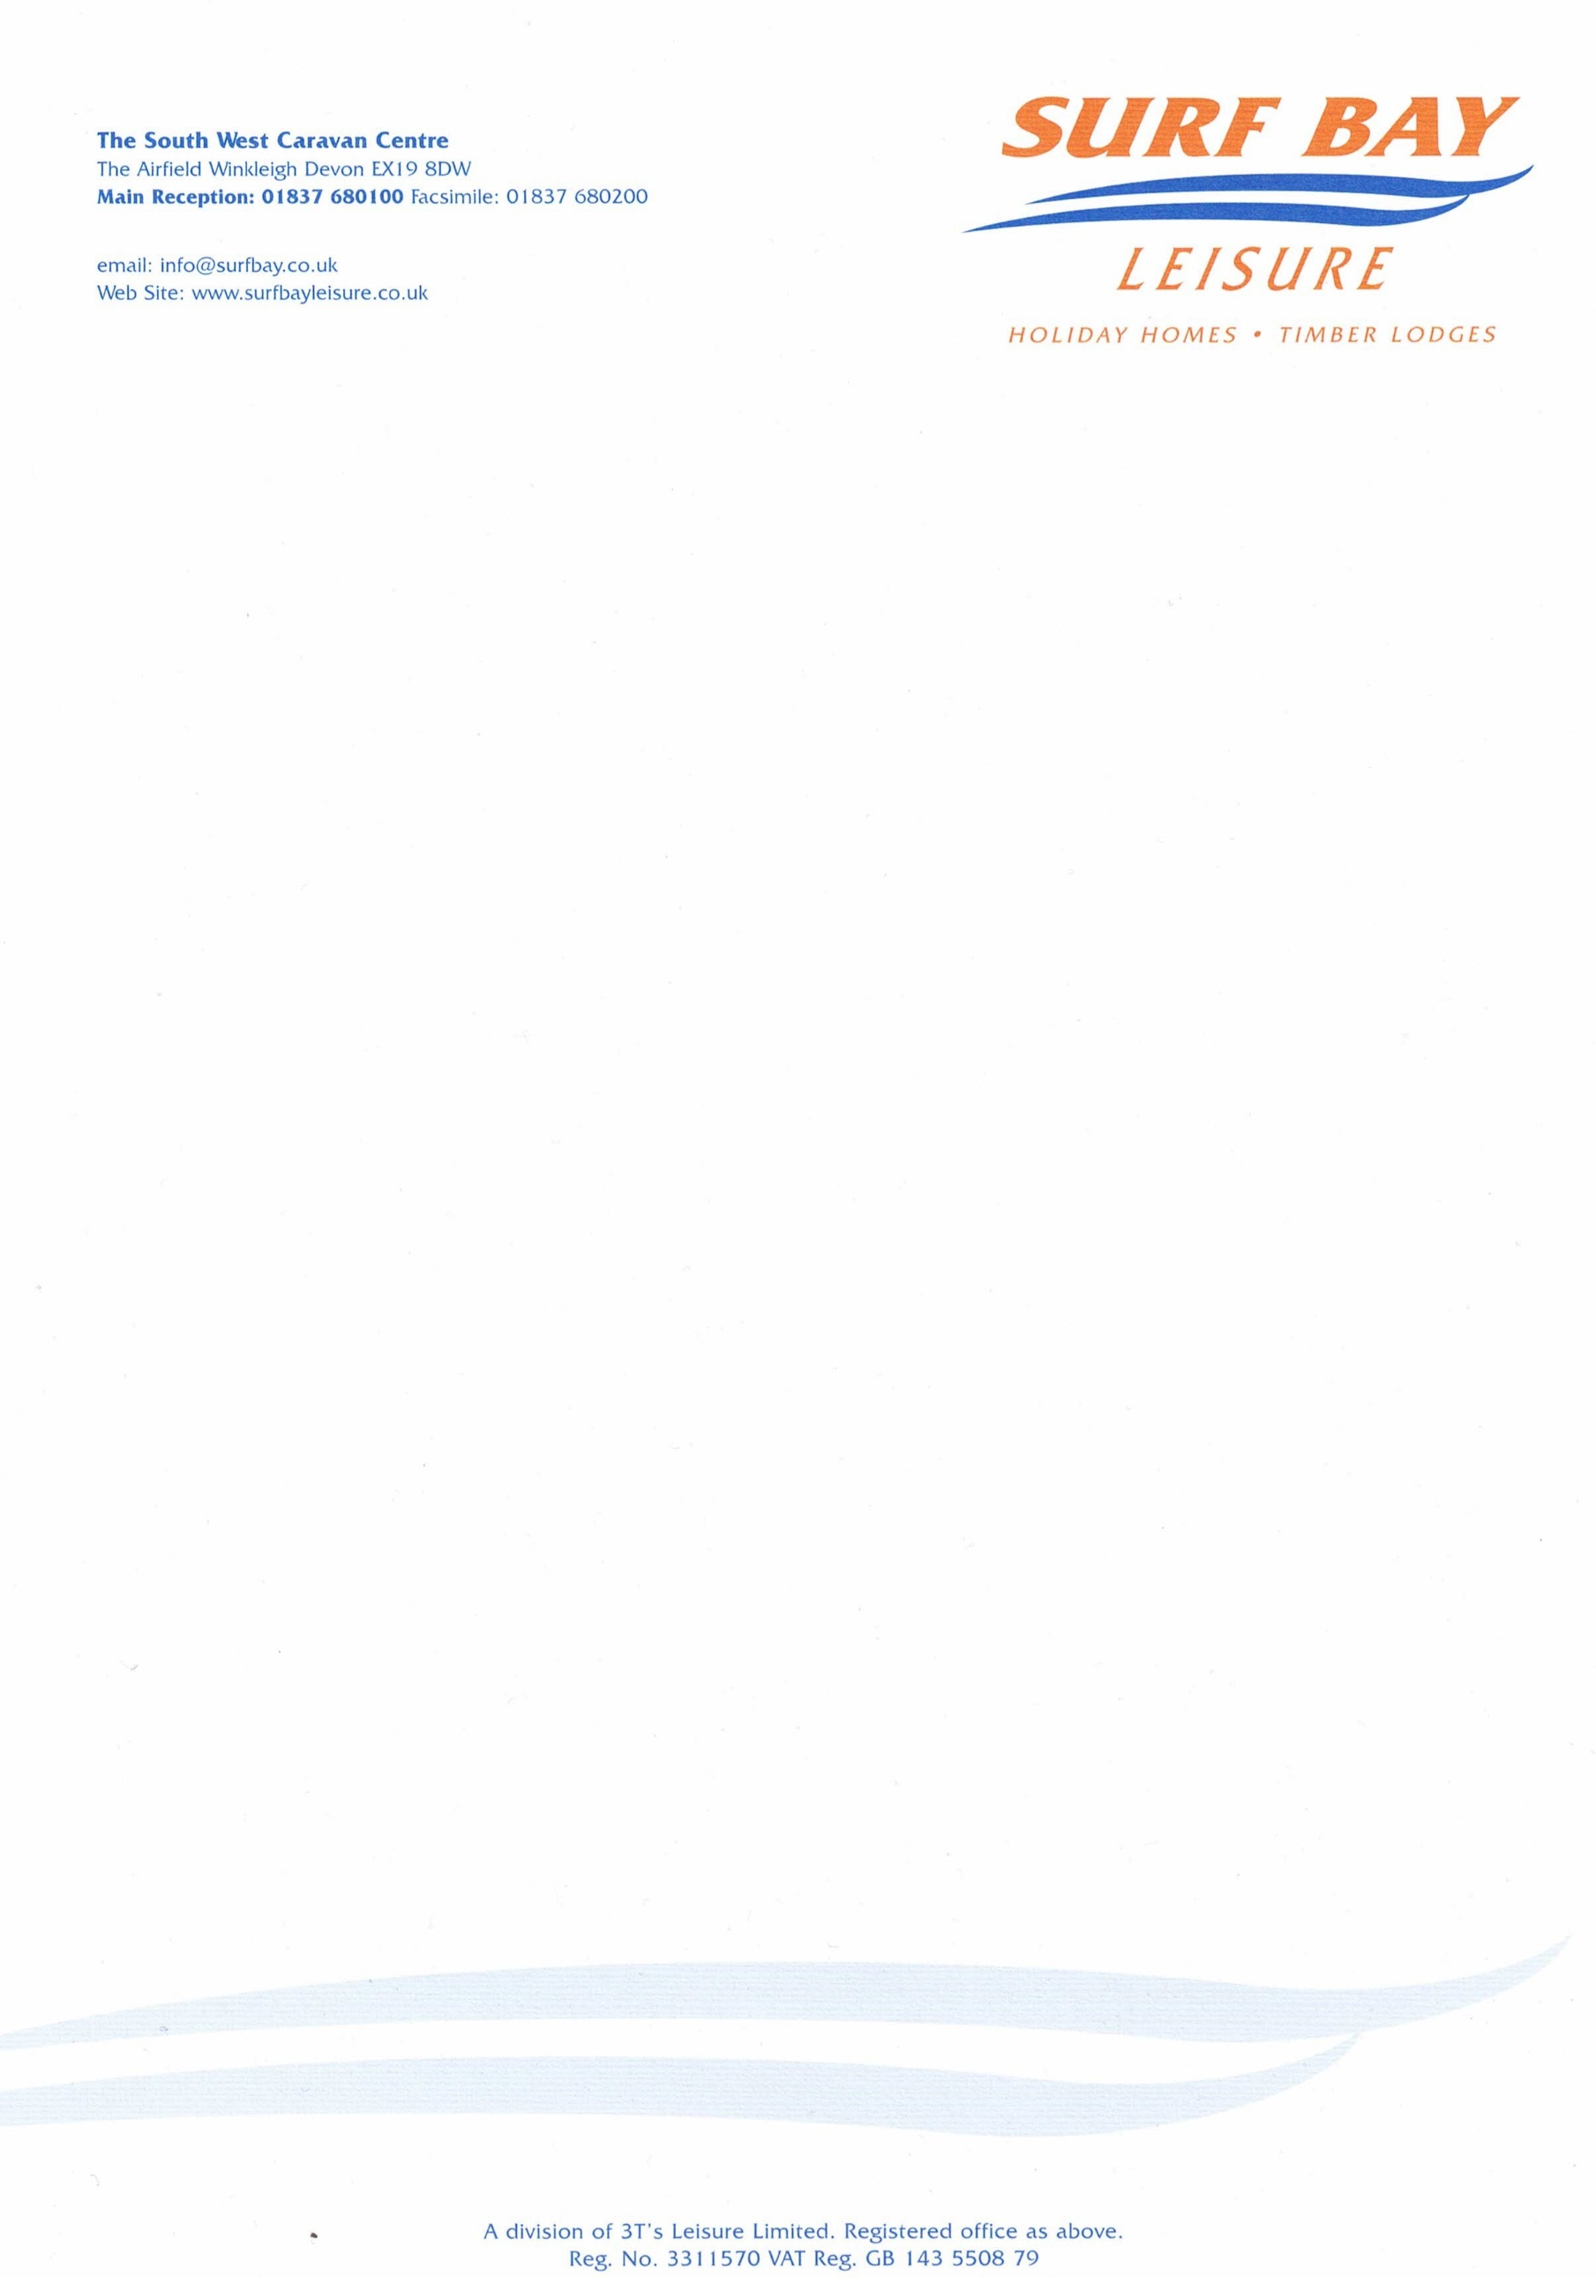

Edithmead Leisure
Edithmead, Near Highbridge
Burnham on Sea
TA9 4HE

29 November 2023

Our Ref: QUOT-3855

Q U O T A T I O N

MAKE: SWIFT
MODEL: vendee lodge
SERIAL NUMBER: 031126H
PITCH NUMBER: D46

MATERIALS: £60.76
LABOUR: £20.00
TRAVEL: 0.00

Sub-total £80.76
VAT £16.15

TOTAL £96.91

Q U O T A T I O N

Edithmead Leisure
Edithmead, Near Highbridge
Burnham on Sea
TA9 4HE

Our Ref: QUOT-3855

P/O No:

I hereby authorise Surf Bay Leisure to order parts and carry out work stated in this quote.

Park is aware of this quote and repair work to be carried out.

SIGNATURE-----------------------------------------------------------------------

PRINT--------------------------------------------------------------------------------

DATE --------------------------------------------------------------------------------

PLEASE SIGN AND DATE AT YOUR EARLIET CONVENIENCE

Invoice details if different from above address:

Name:____________________________________________________

Address:__________________________________________________

__________________________________________________________

__________________________________________________________

Telephone:________________________________________________

Email:____________________________________________________

