
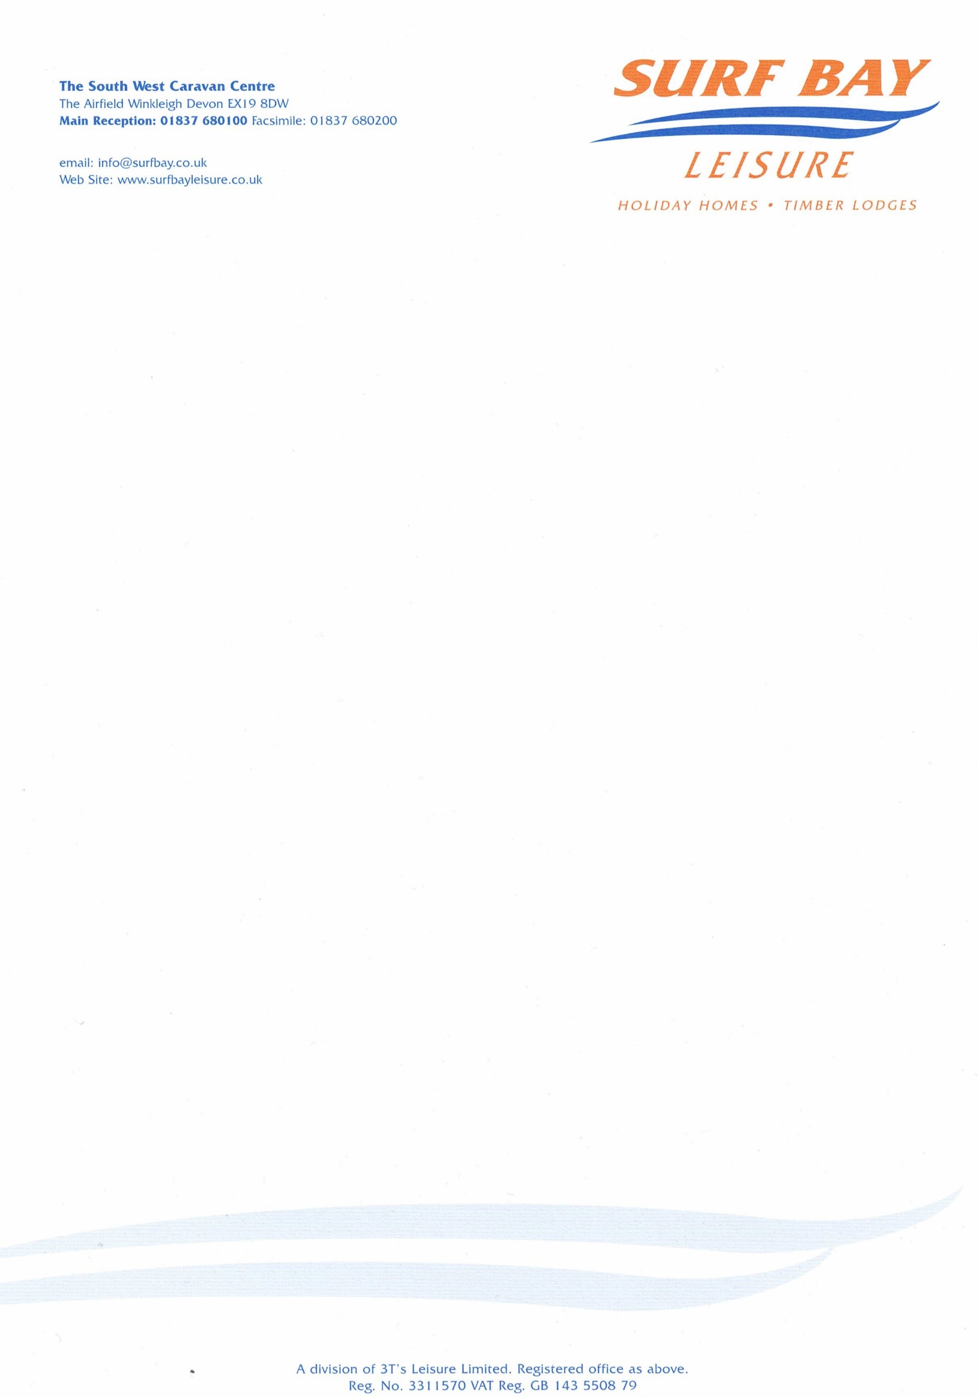

Harlyn Sands Holiday Park
Lighthouse Road, Trevose Head
Padstow
PL28 8SQ

27 February 2024

Our Ref: CHARGE-5246

Q U O T A T I O N

MAKE: swift
MODEL: Loire
SERIAL NUMBER: 039991H
PITCH NUMBER: 271

Replacement main bedroom curtains B328967 Curtain - Master Bedroom (Eyelets)

MATERIALS: £341.25

DELIVERY: £20.00

Sub-total £361.25
VAT £72.25

TOTAL £433.50

Q U O T A T I O N

Harlyn Sands Holiday Park
Lighthouse Road, Trevose Head
Padstow
PL28 8SQ

Our Ref: CHARGE-5246

P/O No:

I hereby authorise Surf Bay Leisure to order parts and carry out work stated in this quote.

Park is aware of this quote and repair work to be carried out.

SIGNATURE-----------------------------------------------------------------------

PRINT--------------------------------------------------------------------------------

DATE --------------------------------------------------------------------------------

PLEASE SIGN AND DATE AT YOUR EARLIET CONVENIENCE

Invoice details if different from above address:

Name:____________________________________________________

Address:__________________________________________________

__________________________________________________________

__________________________________________________________

Telephone:________________________________________________

Email:____________________________________________________

