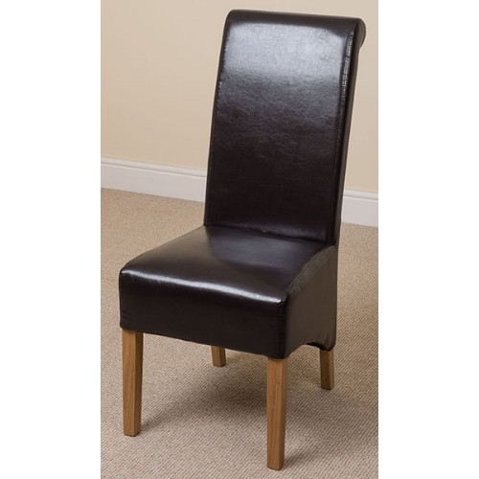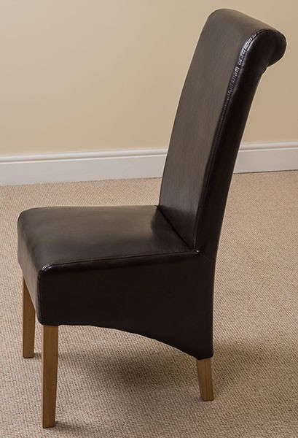

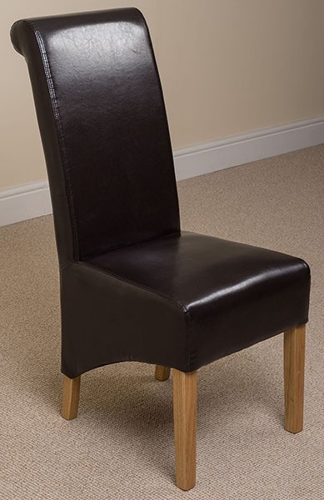

- Width - 47.5 cm
Depth - 50 cm
Back Height - 105.5 cm
Seat Height - 48 cm

